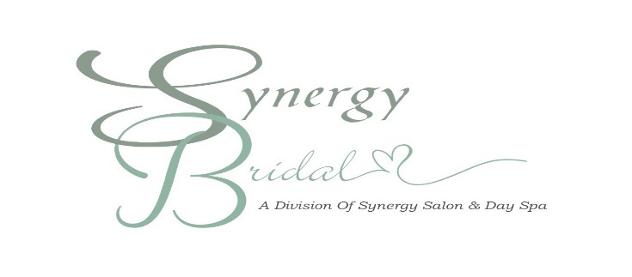

Synergy Bridal Wedding Experience (in salon):

Any service offered at Synergy Salon and Day Spa can be included in your in-salon wedding experience.
- Although there is no minimum when booking your appointments, all services requested must be booked in advance to ensure the stylists have ample time to perform the service.
- We have a relationship with Panera Bread should you want to provide food for the Bridal Party while getting your hair and makeup done. Synergy Bridal will provide you with contact information for your Bridal Party to order catering through Panera Bread. Any catering arrangements, whether through Panera Bread or other vendor chosen by the Bridal Party Representative, are the sole responsibility of the Bridal Party. Synergy Bridal will not order, pickup, or deliver catering for the Bridal Party.

Synergy Bridal Wedding Experience (on location):

- To book a Synergy Bridal Wedding Experience at your location, we require a minimum of $300 of services.
- To ensure the highest satisfaction, a $150 fee will be charged for each stylist. The number of stylists on location varies based upon bridal party size to allow timely application and styling of each member of your group. The number of stylists required will be discussed and agreed upon prior to the wedding date.
- Details of venue and amenities will be discussed and confirmed when booking event.

**Whether in-salon, or on-location, a 50% deposit is due upon booking your event.
** The remaining balance is due 2 weeks prior to your event when on location.

Synergy Bridal Wedding Experience Price List (in salon):

Bridal Hair Package (includes practice Up-do): $190.
Bridal Makeup Package (includes practice session): $150.
Airbrush add-on: $15 (for anyone receiving makeup services, including Bride)
- Complete Bridal Experience (includes practice hair, day-of bridal hair with veil placement, practice makeup, and bridal makeup application): $340.
- Bridal Party Member Hair: $75 (any kind of intricate work: updo, braids, buns, half up, etc.)
- Junior Style (age 5-10): $45
- Anyone with extensions in hair (weft, tape in, or wants clip ins added) $35
- Moms, Grandmothers, and Aunts- Styled hair $60
- Bridal Party Member Makeup: $55 (includes complimentary strip lashes)
- Moms, Grandmothers, and Aunts makeup $45
- Child’s style (age 5 and under): $30 (includes complimentary lip gloss application)

*Please note that a 20% gratuity will be added to all wedding contracts.
**Prices based on Friday and Saturday events. Sunday and/or Holiday event pricing will vary at the discretion of Synergy Bridal.

Feb 2024

Synergy Bridal Wedding Experience Price List (on location):

Bridal Hair Package (includes practice Up-do): $200.
Bridal Makeup Package (includes practice session): $190.
Airbrush add-on: $15 (for anyone receiving makeup services, including Bride)
- Complete Bridal Experience (includes practice hair, day-of bridal hair with veil placement, practice makeup, and bridal makeup application): $390.
- Bridal Party Member Hair: $75 (any kind of intricate work: updo, braids, buns, half up, etc.)
- Junior Style (age 5-10): $45
- Moms, Grandmothers, and Aunts Styled Hair $60
- Anyone with extensions in hair, (weft, tape and or wants clip ins added) $35 add on
- Bridal Party Member Makeup: $75 (includes complimentary strip lashes)
- Moms, Grandmothers, and Aunts Makeup $ 45
- Child’s style (age 5 and under): $30 (includes complimentary lip gloss application)

*Please note that a 20% gratuity will be added to all wedding contracts.
**Prices based on Friday and Saturday events. Sunday and/or Holiday event pricing will vary at the discretion of Synergy Bridal.

Feb 2024

Synergy Bridal Wedding Experience (In Salon)

Bride’s Name: Phone:
Date of Event: Time of event:
Location of Event: Phone:
Address:
Bridal Party Members | Services Requested
We will get ready beforehand at the:
Event Total $_______________ Deposit of 50% due upon booking event $_____________
Balance due 2 weeks prior date of services $_____________
*Deposit due when booking event. Deposits are non-refundable for any reason.

Bridal Party Representative ____________________________________Date: ________________

____________________________________ (Printed Name)

Synergy Bridal Coordinator _____________________________________Date: ________________

____________________________________ (Printed Name)

Synergy Wedding Experience (On Location)

Bride’s Name: Phone:
Date of Event: Time of event: Start/Finish Time:
Location of Event:
Phone:
Getting Ready Location: Phone:
Address:
Bridal Party Members | Services Requested

Event Total $________________________ Deposit of 50% due upon booking event $____________
Balance due 2 weeks prior to date of services $____________
*Synergy Salon & Day Spa is not responsible for any damage to the venue while providing off-site services or additional fees charged by the venue. Liability for any damage to the venue or extra fees is the sole responsibility of the undersigned.
*Deposit due when booking event. Deposits are non-refundable for any reason.

Bridal Party Representative ____________________________________Date: ________________

____________________________________ (Printed Name)

Synergy Bridal Coordinator _____________________________________Date: ________________

____________________________________ (Printed Name)

Hair Extensions Available for Rental

- Price based on consultation.
- ½ cost of extensions and ½ deposit due with signed contract.
- Deposit refunded after extensions are returned.
- We will provide care instructions on how to return extensions.

